05. How to create a ‘Planned Interactions’ Timeline Report

You can use this report to view planned interactions, for example, to view all upcoming Appointments which have been scheduled.

- Click on the Administration ‘cog’ in the vertical menu on the left hand side –

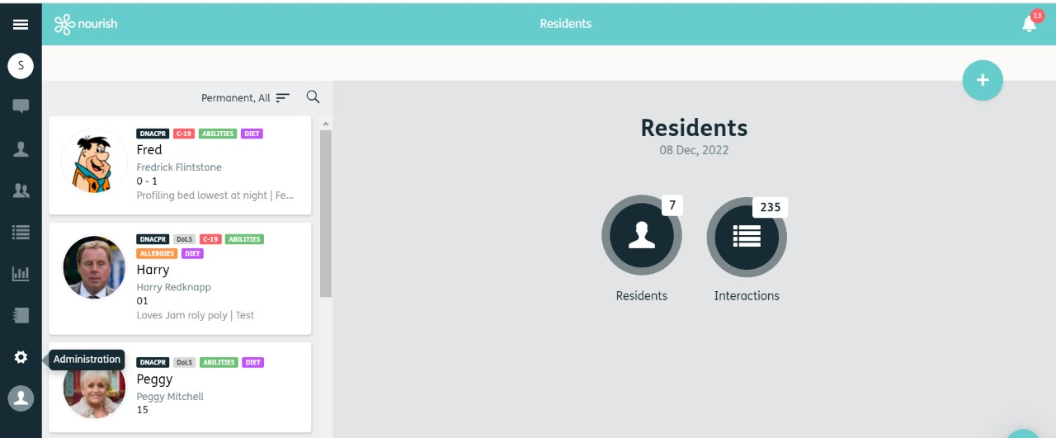
1

- This will open the Administration Menu, click on ‘Reports’ –

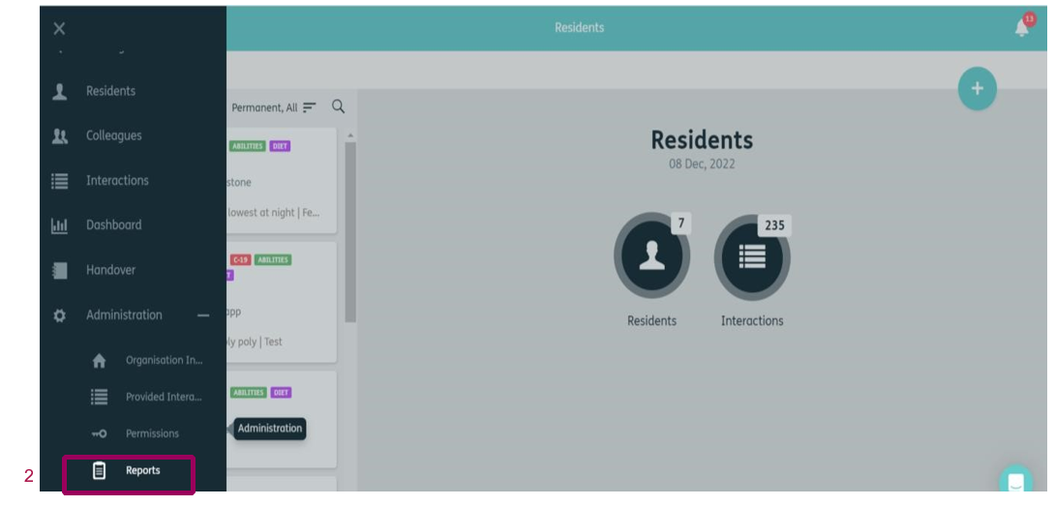

- This will open the reports menu. To create a new report, click on the
‘Blue Plus’ in the top right corner.

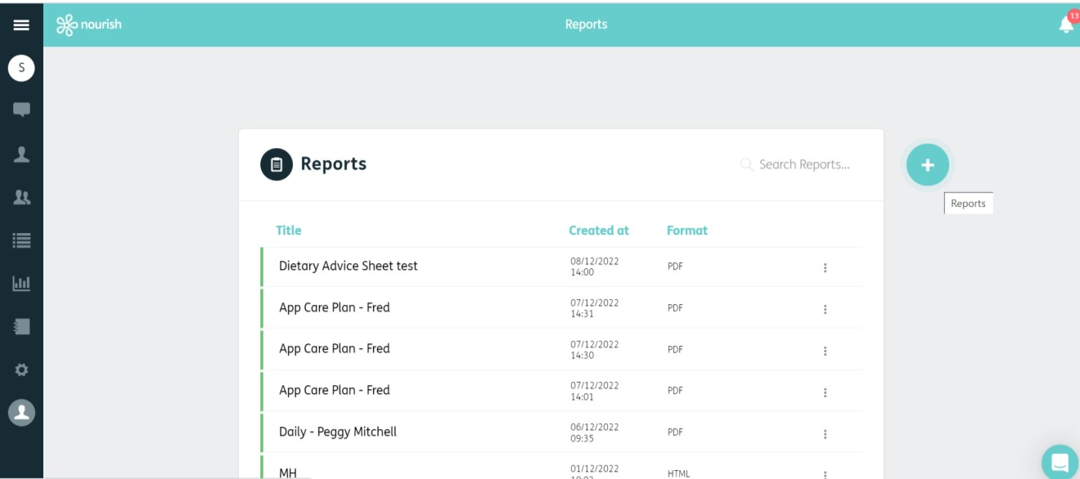

3

- You can now create a new report, choose ‘Timeline’ from the drop down box.

- Give your report a title (remember reports stay in the report list)

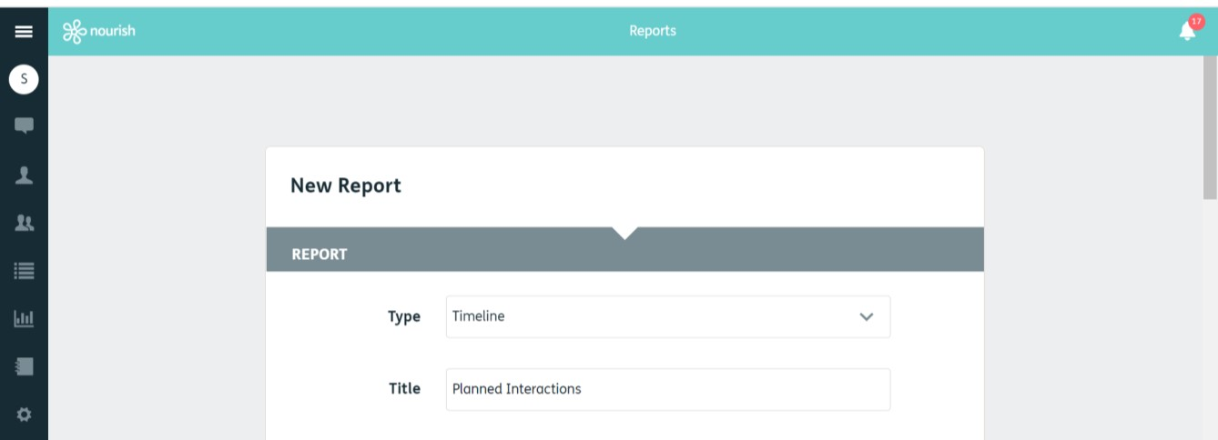

4

5

- Choose your date range – to view upcoming planned interactions this must be in the future. If you wish to view interactions which were planned, and not completed, select your chosen date range.

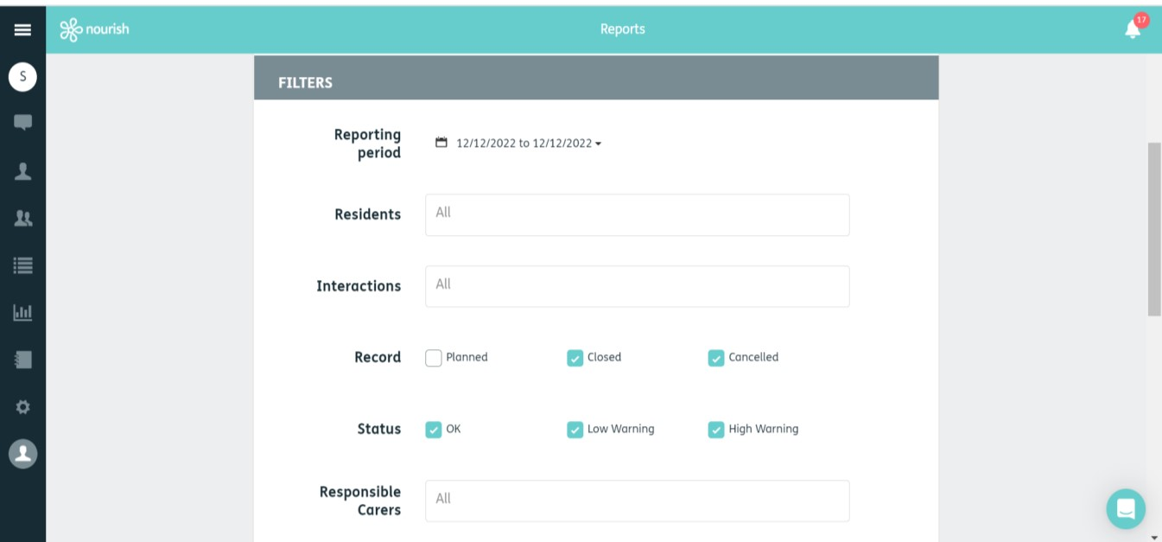

6

- Choose the resident / residents or leave at ‘All’ (if you start typing a name in the box, it will auto-populate) -



7

- Select the interactions (it will auto-populate if you start typing in the box) or leave as ‘All’ if you wish to view all planned interactions.

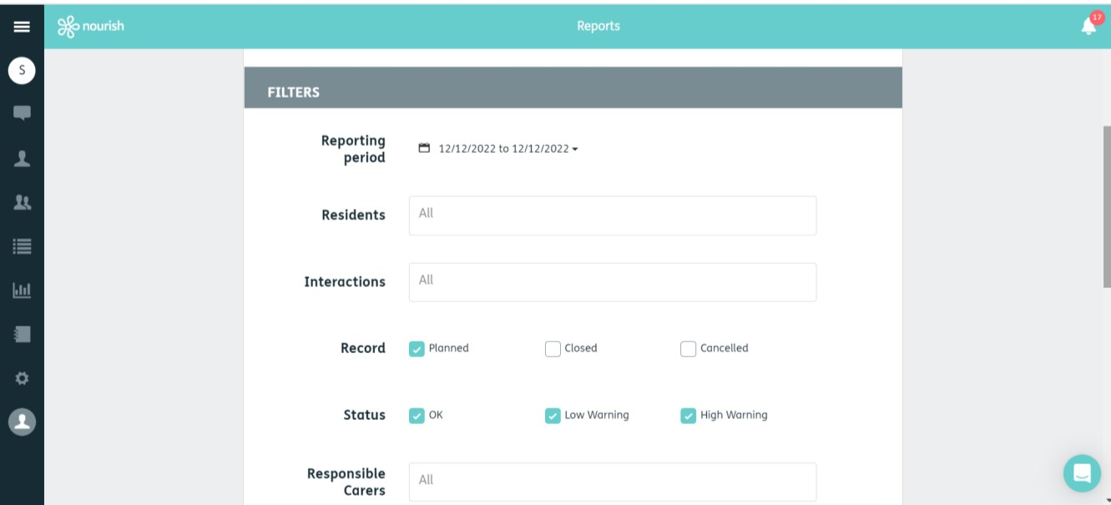

8

- Untick Closed and Cancelled.
- Make sure Planned is ticked.
- Leave all other boxes as they are.

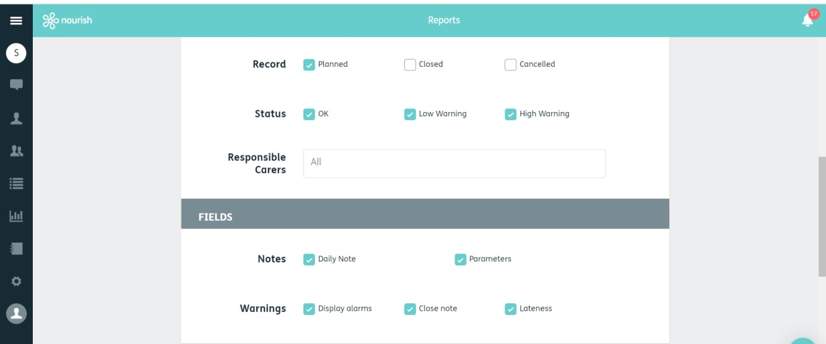

9

10

- You can then select your format (recommended PDF)
- Click Save

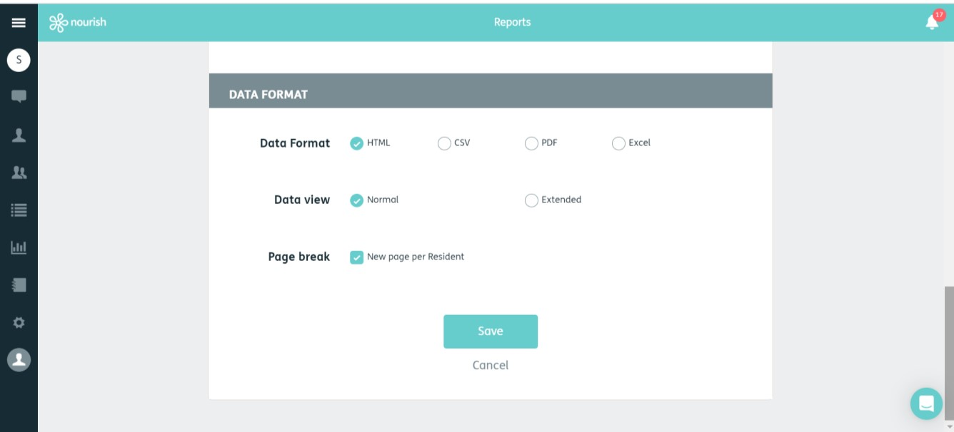

1
3

- You can now download your report.

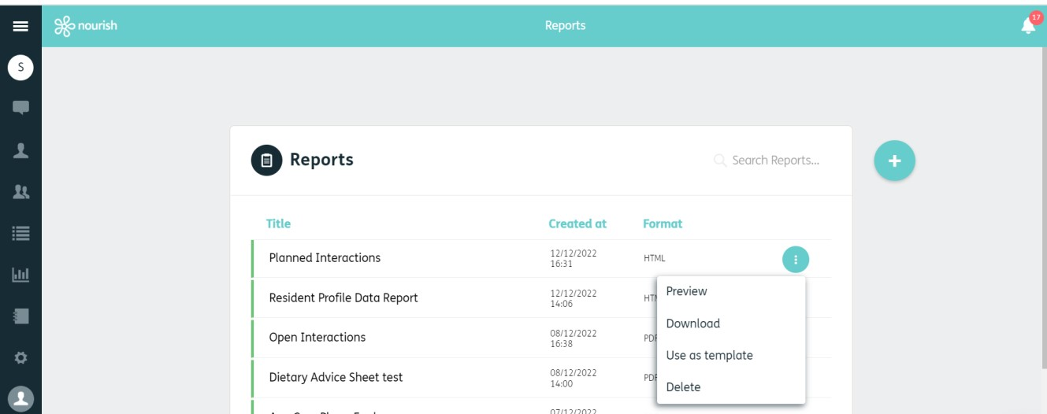

1
4

